**PROJECT REPORT OF BUILDING**

**TEXT EDITOR**

Submitted in partial fulfillment of the requirements for the award of degree of

**COMPUTER SCIENCE AND ENGINEERING (CSE)**

Submitted to

**LOVELY PROFESSIONAL UNIVERSITY**

**PHAGWARA, PUNJAB**



**From 28/09/2020 to 2/11/2020**

BY

SHIVANI KUMARI (11904531)

MANASI MANE (11904624)

TUMMALAPALLI HANITH (11904638)

UNDER THE GUIDANCE OF SAGAR PANDEY SIR

**Abstract**

This report introduces the process of creating part of a text editor. The project is about the text editor which is provides us functionality like creating new documents or text files. Opening existing documents or text files. Save and Save as options. Save files in different formats. Copy, Cut, and Paste text in file. Find and replace text within the document. The major part of the project will introduce us with the tkinter module which is available in python through which we can create multiple windows.

**Acknowledgement**

The satisfaction that accompanies the successful completion of any task would be incomplete without the mention of people whose ceaseless cooperation made it possible, whose constant guidance and encouragement crown all efforts with success. We are extremely grateful to our teacher ‘Mr. Sagar Pande’ for being a source of inspiration and for the constant support in the design, implementation and evaluation of this project. We are thankful to sir for their constant constructive criticism and valuable suggestion, which benefited us a lot while developing the project on “Text Editor”. Through this column, it would be our utmost pleasure to express our warm thanks to him for his encouragement, co-operation and consent as without which we mightn’t be able to accomplish this project.

**Introduction**

This project report will introduce how to build a text editor using the tkinter module. Tkinter is an open source which is used for making websites or any GUI application in python. In the project while making text editor we have used some modules which have different functionalities which we will explain further. In the project report we will demonstrate details of using tkinter to build a text editor: the group component, which is my major contribution to the whole project. Also the technique and process which is showed here can be applied to build the other GUI applications.

**Methods used**

In programming, a module is a piece of software that has a specific functionality. A Python module can have a set of functions, classes or variables defined and implemented. A file containing a set of functions you want to include in your application. We can use modules which are already present and also we can create our own modules.

In this project of text editor we have used some of the modules which we discuss later on. In the project we have used buttons, scrollbar, entry boxes, tkinter window, dropdown list and so much.

**Colorchooser:**

The tkinter module has a package in it named as colorchooser. This package of tkinter module helps in developing the color chooser dialog box. This package has a function named as askcolor() that plays the major role.

askcolor()

This function belongs to the colorchooser package of tkinter module. The function helps in creating a color chooser dialog box. As soon as the function is called, it makes the color chooser dialogue box pop up. The function returns the hexadecimal code of the color selected by the user.

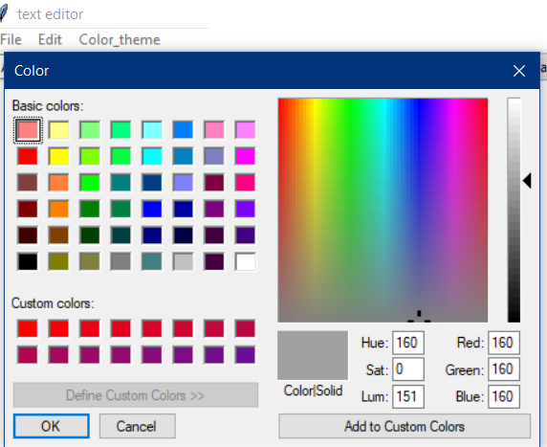

# **tkFileDialog:**

**tkFileDialog** is a module with open and save dialog functions.

## Tkinter Open File

The **askopenfilename** function to creates an file dialog object.

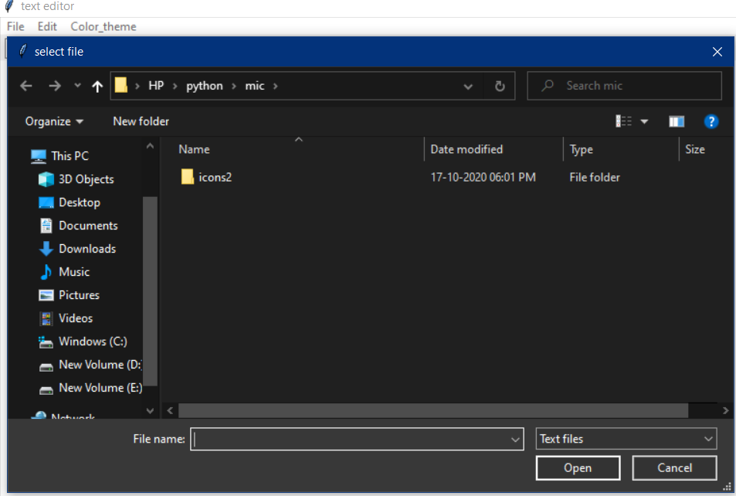

## Tkinter Save File

The **asksaveasfilename** function prompts the user with a save file dialog.

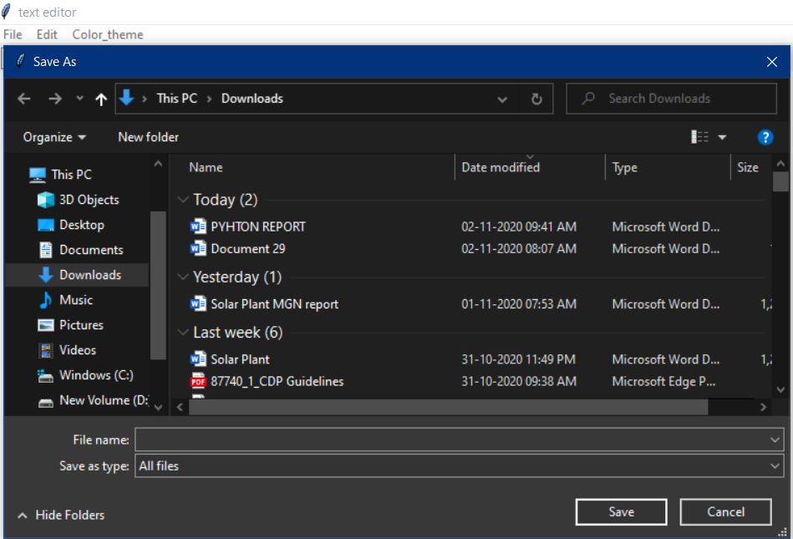

# **tkMessageBox:**

The tkMessageBox module is used to display message boxes in your applications. This module provides a number of functions that you can use to display an appropriate message.

Some of these functions are showinfo, showwarning, showerror, askquestion, askokcancel, askyesno, and askretryignore.

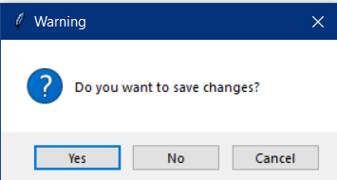

# **os.getcwd() method:**

**OS module**in Python provides functions for interacting with the operating system. OS comes under Python’s standard utility modules. This module provides a portable way of using operating system dependent functionality.  
All functions in os module raise **OSError** in the case of invalid or inaccessible file names and paths, or other arguments that have the correct type, but are not accepted by the operating system.  
os.getcwd() method tells us the location of current working directory

# [**tkinter.ttk**](https://docs.python.org/3/library/tkinter.ttk.html#module-tkinter.ttk)**:**

The [tkinter.ttk](https://docs.python.org/3/library/tkinter.ttk.html" \l "module-tkinter.ttk" \o "tkinter.ttk: Tk themed widget set) module provides access to the Tk themed widget set. The basic idea for [tkinter.ttk](https://docs.python.org/3/library/tkinter.ttk.html" \l "module-tkinter.ttk" \o "tkinter.ttk: Tk themed widget set) is to separate, to the extent possible, the code implementing a widget’s behavior from the code implementing its appearance.

**Important:**

With monokoi color theme and underlined text

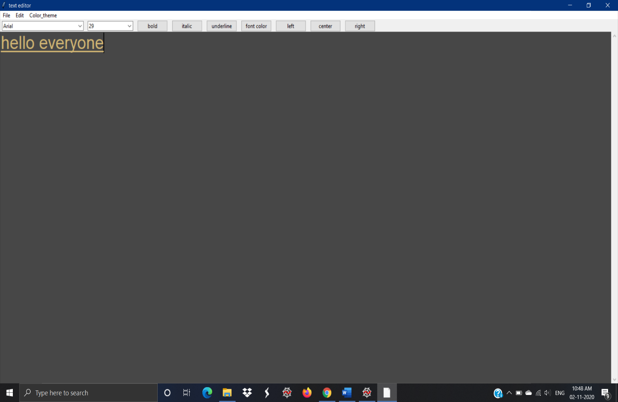

With night blue color theme and font comic sans ms font with bold

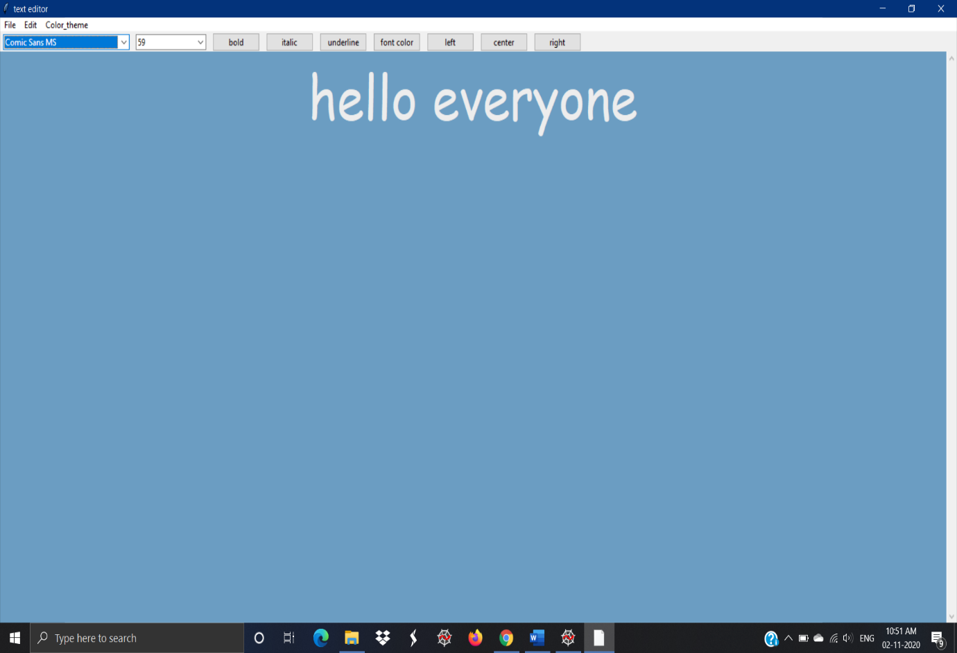

with pink color theme and etalic text which is at right position on the page

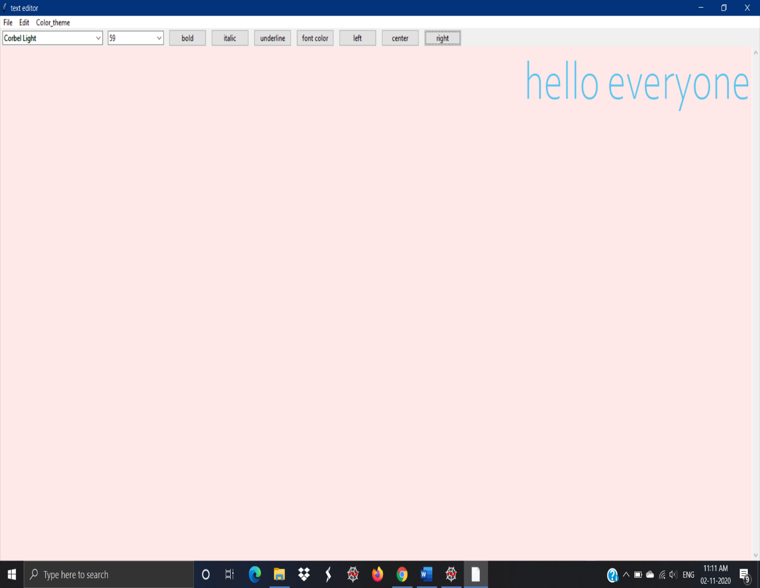

With status bar which is calculating words and characters user have written on the file

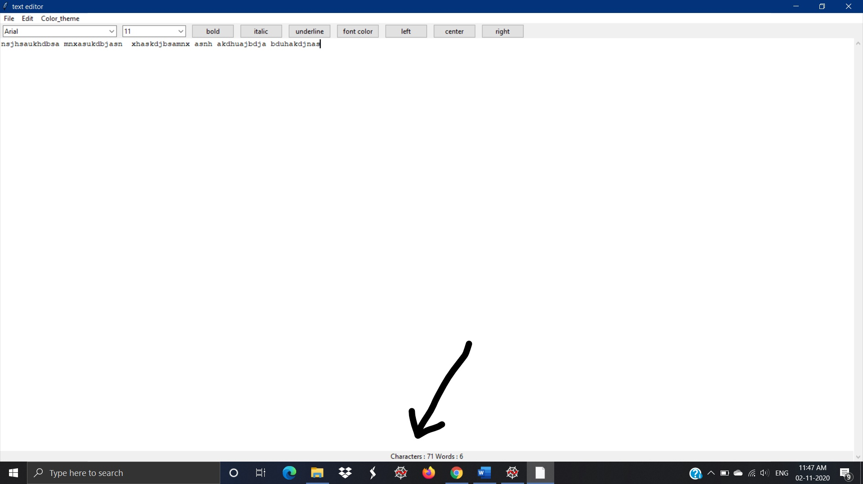

With the edit option which includes copy, paste, cut, clear, find

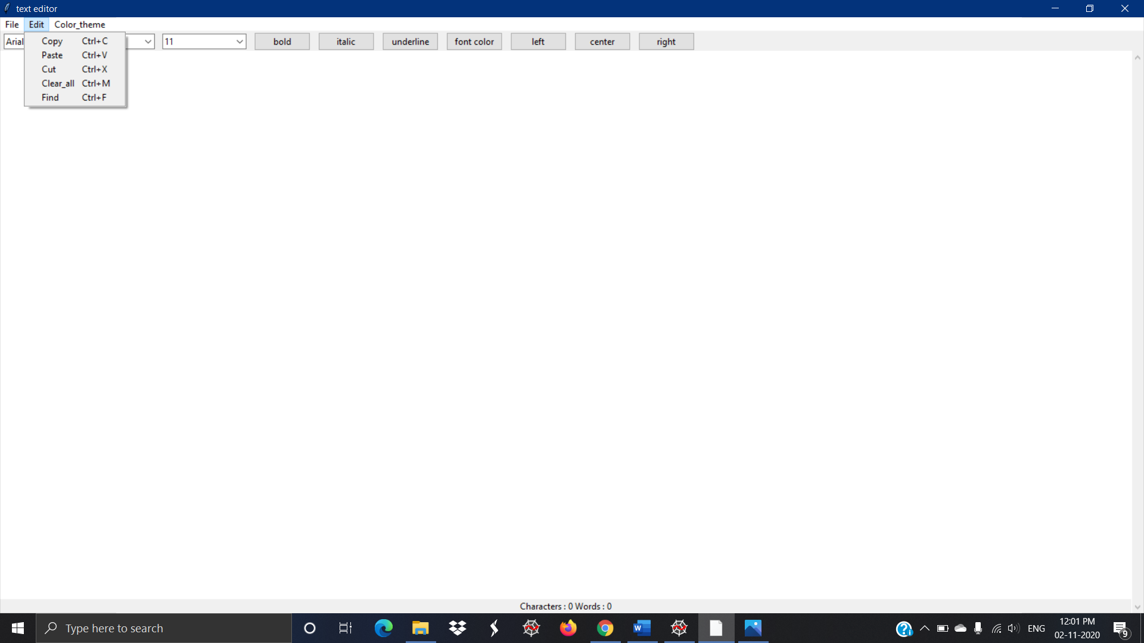

With the find option which can search the word and also it can replace that word throughout the file

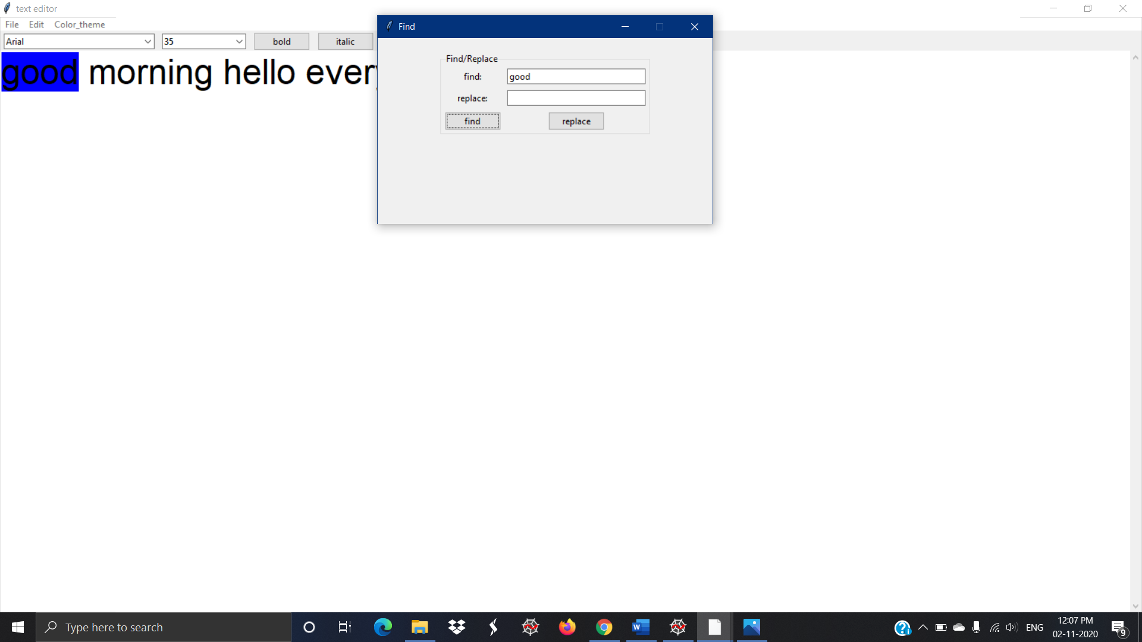

**Conclusion**

The text editor gives us a simple and reliable way to create, save, open and so many options. It provides functionalities to edit, clear, cut, copy, paste, find, replace, change theme change text color, change text size and many more. The experience of making this project also helped us learning a lot of tkinter and its different modules and functions. Once this project passes the testing phase and after developing it with some more functionalities, it can be used for students and also for others. It will make the work much easier. It also can simplify the work for students with reports, submission all in one system. In short, this system will bring great user experience to both students and for other users. The only limitation for this project is that although the we have been testing, it may still encounter problems during real time use. However, even if that happens, the flexibility of tkinter would provide a simple way to fix the problem, as well as add new features into the project.

**References**

1. <https://en.wikipedia.org/wiki/Text_editor>
2. <https://www.codespeedy.com/create-a-text-editor-in-python/>
3. <https://www.instructables.com/Create-a-Simple-Python-Text-Editor/>
4. <https://youtu.be/wRIUnHO_6KY>